| **dlsu_logo.gif** | **Picture 1** |
| --- | --- |

**DE LA SALLE UNIVERSITY**

**COLLEGE OF ENGINEERING**

**SY 2023-2024, TERM 2**

**SOFTWARE DESIGN LABORATORY**

**(LBYCPD2)**

**LABORATORY # 3**

**FUNCTIONAL SPECIFICATION WITH USE CASES**

**NAME:**  **GOCHUICO, DAVID ZACHARY**

**ONG, AIDAN MATTHEW**

**DIMAPILIS, DAVID BRIAN**

**STUDENT ID NUMBER: 12204137**

**12215228**

**12212504**

**STUDENT EMAIL ADD: david\_gochuico@dlsu.edu.ph**

**aidan\_ong@dlsu.edu.ph**

**david\_dimapilis@dlsu.edu.ph**

**STUDENT CONTACT NO: 09228182857**

**09391812517**

**09159734477**

**COURSE CODE: LBYCPD2**

**SECTION:** **EQ1**

**SCHEDULE: SATURDAY (7:30-10:30)**

**INSTRUCTOR: Engr. Bernard G. Yasay**

**STUDENT SIGNATURE: 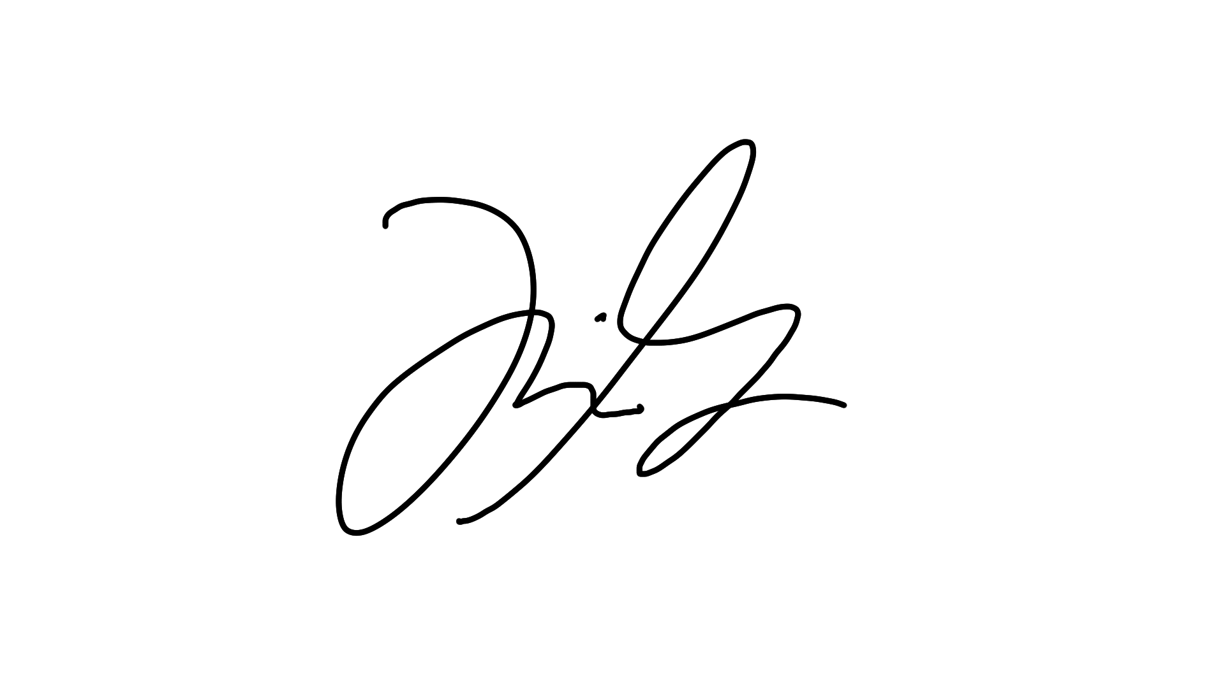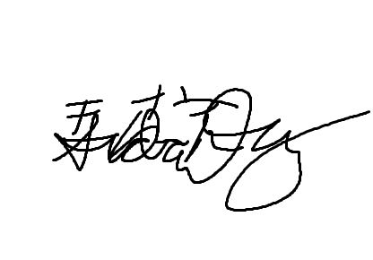**

**DATE SUBMITTED: \_\_, February 2024**

1. **Exercises**

Objective:

To specify the functionality of the approved Service-Learning Project with use cases.

Requirement:

Desktop Computer/Laptop, Office Productivity Tool (MS Word)

Discussion:

Use cases specify the functionality of a system by specifying the behaviour of the system, captured as interactions of the users with the system.

1. Actors - A person or a system which uses the system being built for

achieving some goal.

2. Primary actor - The main actor for whom a use case is initiated and whose goal satisfaction is the main objective of the use case.

3. Scenario - A set of actions that are performed to achieve a goal under some specified conditions.

4. Main success scenario - Describes the interaction if nothing fails and all steps in the scenario succeed.

5. Extension scenario - Describe the system behaviour if some of the steps in the main scenario do not complete successfully.

Create use case for your approved project title, along with the Use Case No.,

Primary Actor, Precondition, Main Success Scenario, and Exception Scenarios.

Kindly follow the format below:

Use Case 1: Put an item up for auction

Primary Actor: Seller

Precondition: Seller has logged in

Main Success Scenario:

Seller posts an item (its category, description, picture, etc.) for auction

2. System shows past prices of similar items to seller

3. Seller specifies the starting bid price and a date when auction will close

4. System accepts the item and posts it

Exception Scenarios:

— 2 a) There are no past items of this category

\* System tells the seller this situation

Main Use Cases for program:

**Use Case 1: POS sales system**

Primary Actor: Customers, Employees

Precondition: Customer is logged into the POS system and the system is operational.

Main Success Scenario:

* Customer logs into XCE
* Customer can view all items in stock and order
* Employees can track all stocks and orders.
* POS System displays customer orders with status (Employees)

Exception Scenarios:

1. No previous orders have been found

* Display message “no prior orders have been found”

**Use Case 2: Receipt Print**

Primary Actor: POS System

Precondition: A successful order transaction has been completed.

Main Success Scenario:

* After a successful transaction, the POS system generates a receipt with items purchased, total price, individual price of each item, quantity, total amount, discounts and tax.
* System sends the receipt data to a connected printer
* Employee takes a printed receipt and gives it to the customer or ships it along with purchased items.

Exception Scenarios:

* There is no order to print a receipt for.

**Use Case 3: Accounting**

Primary Actor: Business Owners

Precondition: Owners or admins are logged in into the accounting system

Main Success Scenario:

* Admin can access the accounting system and navigate to the sales or revenue section.
* System displays a summary of total sales, expenses and profit for a specified time period.
* Admin can generate a financial report, including income statement and expenses.
* System allows for the reconciliation of sales data with the POS system.
* Admin can edit the necessary financial information, analysis and audits.

Exception Scenarios

* No sales data available for the specified time period.
* Discrepancies between POS system and accounting records should alert admin to resolve discrepancies.

1. **Discussion/Analysis about the laboratory activity**

The first use case enables the key functionality of customers placing orders and employees fulfilling them. Customers must be logged into the XCE system to browse available menu listings and current inventory levels. They select desired items and quantities to add to their order. The POS system tracks the status of orders which customers can check on. A key dependency is that customers have existing user accounts, otherwise they cannot access order placement functions. The system also needs to operate online without technical issues to process orders. On the backend, as customers complete orders, inventory quantities are deducted in real-time to reflect purchased items. Orders are conveyed to employees for production and delivery based on status. Exceptions can occur if no previous orders exist for a customer. This may happen on their first purchase, in which case the system displays an informational message about no prior orders instead of order history.

The second use case is targeted to print receipts, with the POS system being the main actor. Printing receipts also includes saving that information into the system for future reference. It is heavily dependent on there being an order already in place. The main success scenario is as follows: After completing a successful transaction, the POS system generates a detailed receipt containing information about the items purchased, including their individual prices, quantities, any applied discounts, taxes, and the total price. This receipt is then sent to a connected printer. An employee retrieves the printed receipt and provides it to the customer, either directly or along with the purchased items. So far in planning there seems to be no exception scenario, other than if there are no available receipts to print. Additionally, the receipt printing functionality provides secondary benefits through storing and archiving sales data. The detailed itemised receipts create an official record of each transaction that captures products purchased, pricing, discounts and final amounts charged. Storing this receipt data over the long term allows sales reporting and analysis to reveal trends on best selling items, busy periods, effectiveness of promotions and pricing, and more. The exceptional case though may arise if there are intermittent connectivity issues that disrupt receipt data from being fully saved into the system, in which case, information could be missing from reporting.

The final case scenario is accounting for transactions and payments. This involves working hand in hand with the receipts. The owner can see expenses and incomes flowing through this system. It is only when the owner is logged in when this case can be accessed. In terms of the success scenario he admin accesses the accounting system to review financial data related to sales, expenses, and profit within a specified time frame. They can generate comprehensive financial reports, including income statements and expense reports. The system facilitates the reconciliation of sales data with the POS system and allows the admin to edit financial information as needed, ensuring accurate analysis and auditing. Exceptions are if sales data is unavailable for the specified time period, the system notifies the admin. Additionally, any discrepancies between the POS system and accounting records trigger alerts for the admin to resolve promptly. This ensures accurate financial reporting and aids in maintaining data integrity.